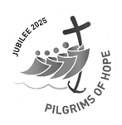
St. Mary’s & St. Columba’s Parish Newsletter Feast of The Holy Family of Jesus, Mary, and Joseph
Email: stmarycastletown@rcaol.org.uk
Phone: 01624 822272
Website: www.manxcatholic.org
Parish Priest: Father Joseph M. Kiganda, CSSp.
In Community: Father Augustine Ogbanna, CSSp. Asst. PP St. Mary’s Douglas.
Deacons: Rev. Alan Molloy a.molloy@rcaol.org.uk
Rev. Graeme Easton g.easton@rcaol.org.uk

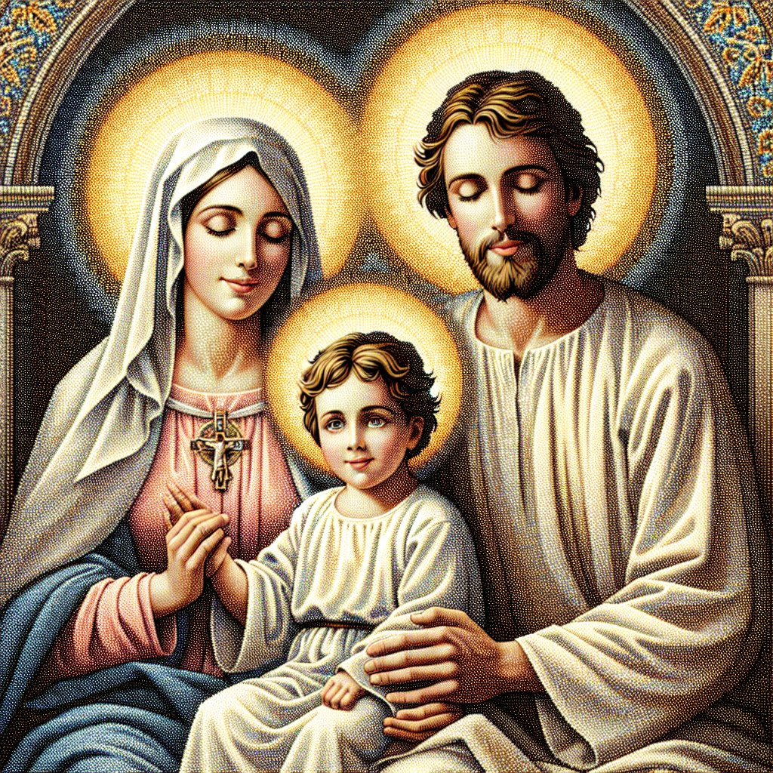

The Holy Family: Jesus, Mary and Joseph
This reflection draws from Familiaris Consortio by Saint John Paul II: “The future of humanity passes by way of the family” (FC, 86). On the Feast of the Holy Family, we are invited to contemplate Jesus, Mary, and Joseph as icons of God’s plan for families. In their Nazareth home, we see not perfection but faithfulness, love, and openness to God’s will.
The Family is a Community of Life and Love: Pope Saint John Paul II teaches that families are called to be a “community of life and love” (FC, 17). The Holy Family exemplifies this through Mary’s yes, Joseph’s obedience, and Jesus’ humble submission, revealing self-giving love characterized by sacrifice, patience, and trust in God.
The Family as the First School of Faith: In Nazareth, Jesus was loved, taught, and nurtured. Familiaris Consortio emphasizes that parents are the primary educators of their children (FC, 36). In the Holy Family, faith is passed on through words and daily examples of prayer, work, silence, and fidelity.
The Family as a Domestic Church: Saint John Paul II refers to the family as the “domestic Church” (FC, 21). In Nazareth, God was worshipped in everyday life, teaching us that holiness is lived in moments of listening, forgiving, working honestly, and caring for one another. Every Christian family is called to be a place where Christ dwells, and love signifies God’s presence in the world.
Hope for Families Today: The Holy Family faced hardships, poverty, exile, and fear, but they trusted God. Today, families are reminded they are not alone; Christ walks with them, calling them to be witnesses of hope, love, and life.
Dear families of God, May Jesus, Mary, and Joseph inspire our families to grow in faith, unity, and love.
Holy Family of Nazareth, pray for our families.
Fr Joseph

Please find below details of this week’s Mass intentions and other services in our Parish of St. Mary’s, Castletown (C/T), and St. Columba’s, Port Erin (P/E).
Week commencing 28th December
Sunday 28th December  Feast of The Holy Family of Jesus, Mary, and Joseph | C/T  P/E | 9 am  11 am | People of the Parish  Special Intention - in thanks for prayers answered
Monday 29th December  Feast of St Thomas Beckett |  |  | No Mass
Tuesday 30th December  Sixth day of Octave of the Nativity of the Lord | P/E | 10 am | Ian Younger RIP and Rob Croft birthday thanksgiving.
Wednesday 31st December  Seventh day of Octave of the Nativity of the Lord | C/T | 10 am
Thursday 1st January 2026  Solemnity of Mary, the Holy Mother of God | P/E | 10 am | Annie Bannister
Friday 2nd January  Memorial of St Basil the Great and Gregory Nazianzen | C/T | 10 am
Saturday 3rd January  Weekday of Christmas before Epiphany | C/T | 10 am  10 45 am | Intentions to Our Lady of Rushen  Adoration and Confession
Sunday 4th January  Second Sunday after the Nativity | C/T  P/E | 9 am  11 am | People of the Parish  Thanksgiving for request granted

Responsorial Psalm:
Blessed are all who fear the Lord and walk in his ways.

Gospel Acclamation:
Alleluia, Alleluia
Let the peace of Christ rule in your hearts, let the word of Christ dwell in you richly.
Alleluia

Communion Antiphon:
Our God has appeared on the earth and lived among us.

Jubilee Year 2025: During the year of the Jubilee the parish motto will be, “Rejoice in hope, be patient in suffering, persevere in prayer.” (Rom 12:12)

Welcome: Today we welcome Travis Kai and Valentina Luna Newman who will be baptised at St Mary’s. Please pray for Travis, Valentina and their families.

Mass Intentions: Ian Younger, Rob Croft, Annie Bannister, Ruth Castillo, and special intention.

Parish Diary
Events to be added soon

If you are aware of future events, please let us know so we may add them to the diary. Social Club Committee contact details: Susan 460514, Nick 431606, Dee 437487, or Lynn 472867.

Second Collections from January to June
Sunday 15th March | Nugent
Sunday 3rd April | Holy Places
Sunday 26th April | Priest Training Fund
Sunday 17th Mary | World Communications
Sunday 21st June | Day for Life

“Let us prepare the way for the Lord by making our hearts humble and ready to receive Him” St. Gregory the Great

“Rejoice in hope, be patient in suffering, persevere in prayer”
Archdiocese of Liverpool A charitable incorporated organisation
(registered charity number 1199714)

