St. Mary’s & St. Columba’s Parish Newsletter
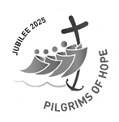
Solemnity of the Nativity of the Lord
Email: stmarycastletown@rcaol.org.uk
Phone: 01624 822272
Website: www.manxcatholic.org
Parish Priest: Father Joseph M. Kiganda, CSSp.
In Community: Father Augustine Ogbanna, CSSp
Asst. PP St. Mary’s Douglas.
Deacons: Rev. Alan Molloy a.molloy@rcaol.org.uk
Rev. Graeme Easton g.easton@rcaol.org.uk

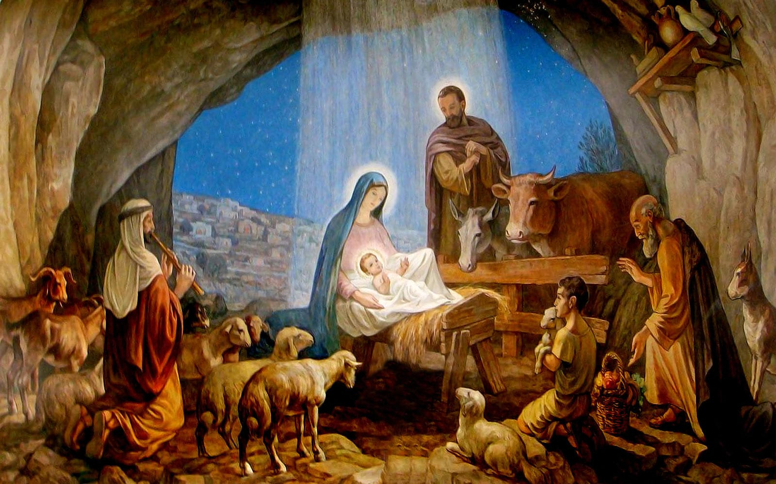

The Word became flesh and dwelt among us. (John 1:14)

On Christmas Day, the Church proclaims a mystery that changes everything: God has come to live among us. In the birth of Jesus, the eternal Word enters our fragile world, bringing hope, peace, love, and joy, not as abstract ideas, but as a living Person.

Christmas brings Hope: Isaiah announces, “How beautiful upon the mountains are the feet of the one who brings good news.” (Isaiah 52:7) Christmas renews our hope because God has not abandoned humanity. Even in darkness, suffering, or uncertainty, Christ is born among us. Hope is no longer wishful thinking; it is grounded in Emmanuel, which means God-with-us.

On Christmas Day, the Church proclaims a mystery that changes everything: God has come to live among us. In the birth of Jesus, the eternal Word enters our fragile world, bringing hope, peace, love, and joy, not as abstract ideas, but as a living Person.

Christmas brings Hope: Isaiah announces, “How beautiful upon the mountains are the feet of the one who brings good news.” (Isaiah 52:7) Christmas renews our hope because God has not abandoned humanity. Even in darkness, suffering, or uncertainty, Christ is born among us. Hope is no longer wishful thinking; it is grounded in Emmanuel, which means God-with-us.

Christmas brings Peace: Isaiah continues, “The Lord has comforted his people; he has redeemed Jerusalem.” (Isaiah 52:9) The peace of Christmas is not merely the absence of conflict, but the deep assurance that God is reconciling the world to Himself. In Jesus, God speaks peace to restless hearts and divided communities.

Christmas brings Love: Saint John tells us, “To all who received him, he gave power to become children of God.” (John 1:12) Christmas reveals a love that is generous and personal. God does not remain distant; He gives Himself completely. In Christ, we are welcomed into God’s own family, loved not because of what we do, but because of who God is.

Christmas brings Joy: And finally, joy overflows: “From his fullness we have all received, grace upon grace.” (John 1:16) True Christmas joy is born from grace—the unearned gift of God’s presence. It is a joy that endures beyond the season because Christ stays with us.
Christmas Message: As we celebrate Christmas today, may hope inspire us, peace bring us comfort, love guide our actions, and joy enhance our faith. Let’s carry this light into the world, remembering that the Word has become flesh and lives among us, today and always.

Merry Christmas to you all! From Fr Joseph and Fr Augustine

Please find below details of this week’s Mass intentions and other services in our Parish of St. Mary’s, Castletown (C/T), and St. Columba’s, Port Erin (P/E).
Thursday 25th December  Solemnity of the Nativity of the Lord | C/T  P/E | 9 am  11 am | SVP Christmas List  Jim Doherty
Friday 26th December  Feast of St Stephen | C/T | 10 am | Lucy and Benny Gresty (Ann)
Saturday 27th December  Feast of St John | C/T | 10 am  10 45 am | Intentions to Our Lady of Rushen  Adoration and Confession
Sunday 28th December  Feast of The Holy Family of Jesus, Mary and Joseph | C/T  P/E | 9 am  11 am | People of the Parish  Special Intention - in thanks for prayers answered
Monday 29th December  Feast of St Thomas Beckett |  |  | No Mass
Tuesday 30th December  Sixth day of Octave of the Nativity of the Lord | P/E | 10 am | Ian Younger RIP and Rob Croft birthday thanksgiving.
Wednesday 31st December  Seventh day of Octave of the Nativity of the Lord | C/T | 10 am
Thursday 1st January 2026  Solemnity of Mary, the Holy Mother of God | P/E | 10 am
Friday 2nd January  Memorial of St Basil the Great and Gregory Nazianzen | C/T | 10 am
Saturday 3rd January  Weekday of Christmas before Epiphany | C/T | 10 am  10 45 am | Intentions to Our Lady of Rushen  Adoration and Confession
Sunday 4th January  Second Sunday after the Nativity | C/T  P/E | 9 am  11 am | People of the Parish  Thanksgiving for request granted

Responsorial Psalm
All the ends of the earth have seen the salvation of our God.

Gospel Acclamation:
Alleluia, Alleluia
A hallowed day has shone upon us
Come, O nations, and adore the Lord;
For today a great light has come down to earth.
Alleluia, Alleluia

Communion Antiphon:
All the ends of the earth have seen the salvation of our God.

Jubilee Year 2025: During the year of the Jubilee the parish motto will be, “Rejoice in hope, be patient in suffering, persevere in prayer.” (Rom 12:12)

Nativity Service: Many thanks to everyone who came to the nativity last Sunday and made it such a joyful celebration. Thanks to all the narrators, actors, parents, and nativity helpers, plus all those who worked behind the scenes making food, preparing the hall, cleaning, and tidying up afterwards. Another wonderful Parish team effort. The donations for the CAFOD Middle East Humanitarian Appeal came to a fantastic £427.10.

Mass Intentions: Walter Gibbons, Thomas, Teresa, and Oliver Lannon, Fr. Paddy Gaffney, Jim Doherty, Lucy and Benny Gresty and Special Intention.

“Let us prepare the way for the Lord
by making our hearts humble and ready to receive Him”
St. Gregory the Great

“Rejoice in hope, be patient in suffering, persevere in prayer”
Archdiocese of Liverpool A charitable incorporated organisation
(registered charity number 1199714)

